

**Computer & Electronic Engineering**

**Final Year Project "Music Host Interface"**

**Sprint 5: Week 2 Log**

**Thomas Flynn**

**Project Supervisor: Brian O'Shea**

**08/02/16 - 14/02/16**

**Entry 3: 13/02/16**

I renamed files and moved the server code into the the "ServerModel" class.

**Entry 2: 13/02/16**

Today I was able to print out what I typed into my login fields. I ran into problems with "TextField" variable and had to resort to using a "PasswordField" variable for both the login fields. I also figured out to inject the model object into all 3 screen controllers today, which is a big success.

**Entry 1: 12/02/16**

I successfully add the Gitignore file to my Repositories. This ended up taking longer than I would've liked. But it's done now.

**Tasks completed:**

created Database with foreign keys for users

added git ignore for both FYP-GUI and GYP-Android repositories.

Moved code from Controllers to Model class

Figured out how to relate songs from database to media players array list

Created FYP-Report Repository

Started a Report template

**Database setup:**

**CREATE** **TABLE** HostLogin

(

P_Id **int** **NOT** **NULL**,

username **varchar**(255) **NOT** **NULL**,

userpassword **varchar**(255),

**PRIMARY** **KEY** (P_Id)

)

**CREATE** **TABLE** usersongs

(

S_Id **int** **NOT** **NULL**,

songname **varchar**(255),

artistname **varchar**(255),

P_Id **int**,

**PRIMARY** **KEY** (S_Id),

**CONSTRAINT** song_PerUser **FOREIGN** **KEY** (P_Id)

**REFERENCES** hostlogin(P_Id)

)

**GIT Repositories: FYP-Android (Master) -**

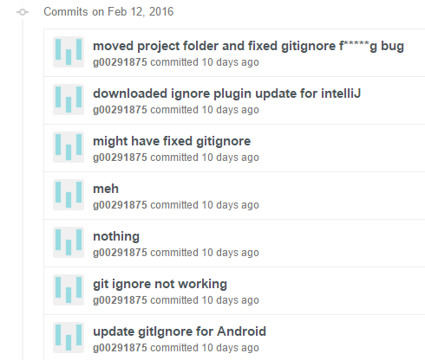

**FYP-GUI (Master)**

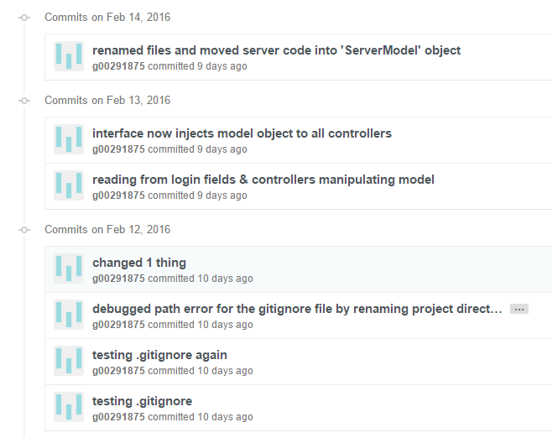

**Board at the start of the week:**

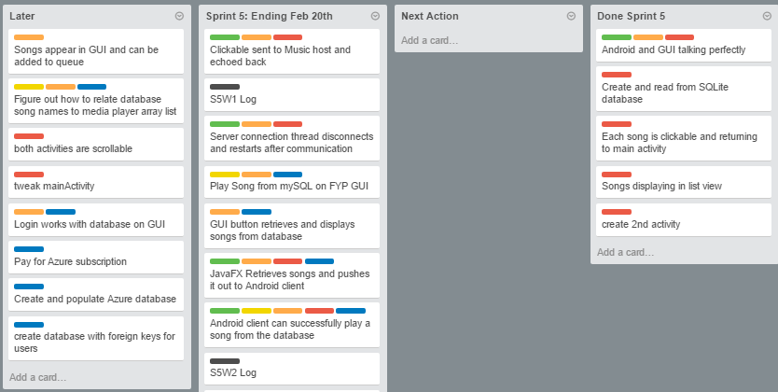

**Board at the end of the week:**

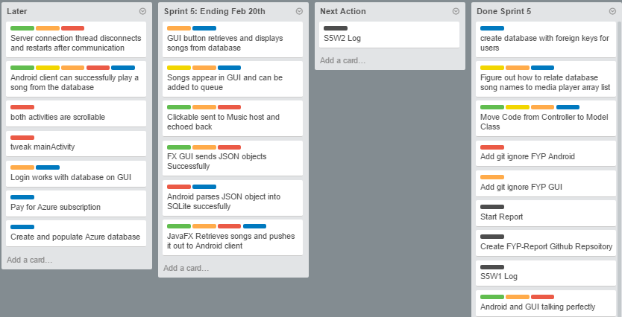

**Weekly time Log bar chart:**

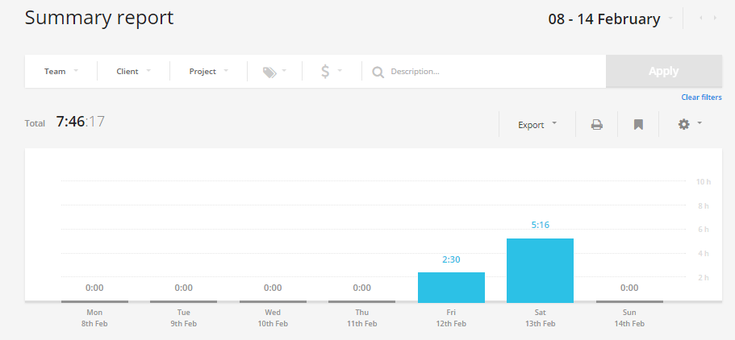

**Weekly Time Log:**

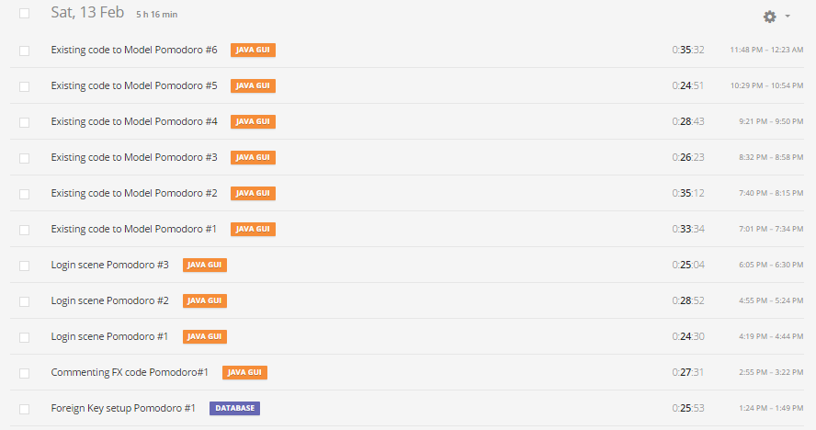

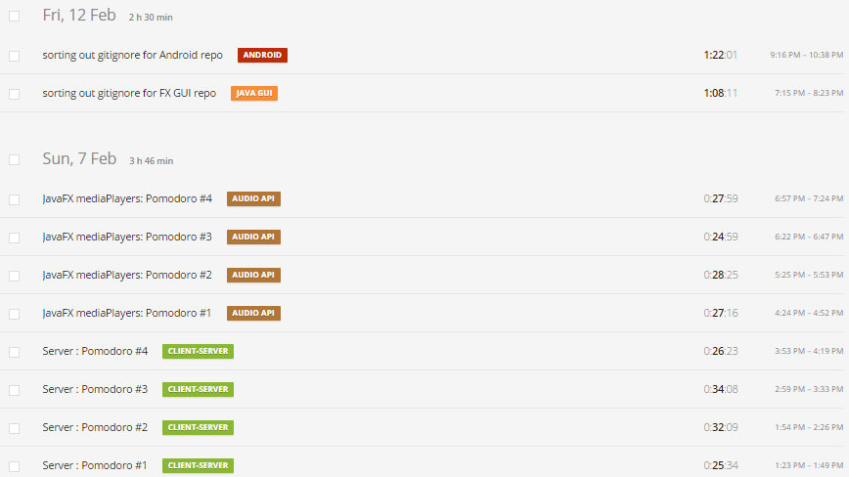

**Weekly log Pie Charts:**

